trackle: track your vehicle.!
Always remember where you parked

Neha Mahajan*
nsmahajan@wpi.edu
Arun Vadivel*
avadivel@wpi.edu

*Department of Computer Science, Worcester Polytechnic Institute

ABSTRACT
In today’s tight-scheduled life, the average person has the need to remember many things, one among which is the location of the parked vehicle. Surveys show that one in every two drivers (52%) has forgotten where they parked their vehicle and the total time spent in searching for their parked vehicle is estimated to be 200 man-years. To minimize this ineffective time expenditure, we propose trackle, a GPS based Android application that automatically identifies the location of the parked vehicle. A user study and survey with 8 participants indicates a positive response to trackle. Seven of the eight participants in the study found it to be implementable in their everyday life.
Keywords
Parking location reminder, Smartphone sensing, GPS.

INTRODUCTION & MOTIVATION
It is common for people to forget where they parked their vehicle. As a study by insurance.com^{[1]} shows, out of 2000 drivers (1000 male and 1000 female), about 52% (44% of total male and 59% of total female drivers) forgot where they parked their vehicles. Another survey^{[2]} shows that the total time spent searching for parked vehicles is estimated at 200 man-years. This is a major time expense considering the fact that the first automobile was manufactured in 1886 by Benz Patent Motor Car which means that cars have been around for only 130 years. This indicates that for every 1 year spend in manufacturing vehicles; 1.53 years are spent just searching for parked cars. Moreover, as the number of public go-to places increases every year with an even higher increase in the sales of vehicles and increasing congestion in the parking lots of urban cities, the time spent in searching for parked vehicles is bound to increase.
Given this background of time wasted in searching for parked vehicles, we attempt to tackle this problem with trackle, an Android based smartphone application developed to automatically or manually record the vehicle’s location after it has been parked. Users can then find their parked vehicle and the shortest route to get there with the click of one button.
The contribution of this paper is two-fold. First, we present our novel approach used in trackle that detects and saves the vehicle’s parked location without external devices or peripheral equipment. Second, we present the results from the user study that resulted in an overall positive response regarding integrating the application to the user’s everyday life.
In the remainder of this paper, we discuss related work in Section 2. Next we define the objectives of the application in Section 3. We then present our design approach for trackle in
*Department of Robotics Engineering, Worcester Polytechnic Institute

Section 4 and implementation specifics in Section 5. Section 6 describes the user study and survey. Discussions are included in Section 7 and we conclude in Section 8.

RELATED WORK
ParKing Reminder: Find my car^{[3]} is an application that performs a similar function. However the major difference is that ParKing Reminder forces the user to manually tag the vehicle’s parking location with a button click. In cases where the user’s vehicle is Bluetooth enabled and paired with the smartphone, the application saves the location at the time of disconnection of the vehicle’s Bluetooth device indicating turning off of the vehicle’s ignition. However, this makes the application dependent on external factors such as the Bluetooth on the vehicle while trackle works independently as a self reliant application.
ParkSense^{[4]} is an application developed for a parallel type of problem. This application addresses the issue of searching for vacant parking spots. The application also considers energy efficiency and hence utilizes relative WiFi signal strengths as the core parameter to detect vehicle movement from a parked location and indicates that a parking slot has become vacant and this information is passed around to all other users of the application thus reducing the burden of searching for parked locations. However, our application deals with the issue of finding the vehicle once it has been parked. This is a complementary problem to the one considered in ParkSense.
Typical systems that currently address this issue require some additional peripheral hardware with GPS features installed on the vehicle. The mobile application communicates with this peripheral device to request the GPS location of the vehicle.
Other systems use external devices in the vehicle such as an audio system with Bluetooth capability. Mind Mobile^{[5]} is one such system which uses the Bluetooth and GPS of an additional device that also functions as an in-vehicle USB charger. Mind Mobile uses the external device to send a trigger to the smart phone when the vehicle is changed to park mode and the ignition is turned off. The application on the mobile device saves the location at the time instant when the trigger is received.
The major difference between these systems and trackle is the design decision to make trackle a self-sufficient, standalone application that does not require any external or peripheral devices to be fully functional. This reduces potential failure modes of the additional external devices and hence improves reliability of the application.

OBJECTIVES
The primary objective of trackle is to automatically or manually save the parked location of the user’s vehicle and to display the path back to the parked vehicle upon user’s request.
The secondary objective is to make the application convenient to use by providing relevant features such as history tracking, capability to capture photos and notes and parking cost calculator.
The tertiary objective of the application is to make its UI (User Interface) minimalistic and elegant.

DESIGN APPROACH
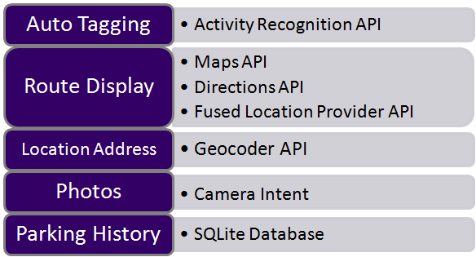
Fig.1: Design Approach

There are two modes of operation of the application – Manual and Auto. Both modes operate in the same way except for one difference. In the Auto mode, the parked location is automatically saved while in the Manual mode, the user has to save the location of the parked vehicle manually by clicking a button. We explain the design approach of the Manual mode first and subsequently that of the Auto mode. A flow chart of the manual mode is shown in Fig.2 and for the auto mode in Fig.3.
In the Manual mode, the user clicks the “Park” button once the vehicle is parked. The Fused Location Provider API is used to get the latitude and longitude of the location. The application creates a new Universally Unique Identifier (UUID) and saves the latitude and longitude of the user’s location when the button is clicked. This UUID and its corresponding latitude and longitude is then stored to the database. For database functionality, the SQLite Database is used. The application provides the ability to capture three photos and also take notes on the parked location. Camera Intent was used for capturing photos. If the user has parked in a paid parking lot, the duration of parking and the cost can be entered using sliders. All of this is also stored in the database.
In the Auto mode, the parked location is automatically detected. This is done using the Activity Recognition API. The website in ^{[6]} gives a list of activities that the Activity Recognition API can recognize. The user’s Activity is predicted every one second. The application checks if the predicted activity transitions from “IN_VEHICLE” to any other state. If this is true, the location at the instant that the transition occurs is saved temporarily and a flag is set to true. Once the flag is set to true and the user’s location changes 30 meters or greater away from the temporarily saved location without a transition back to IN_VEHICLE, this is indicative of the user having parked his vehicle and this is the “parked” condition. If the activity of the user transitions to IN_VEHICLE before 30 meters, the flag is reset to false and hence, the temporarily saved location is not saved to the database. In the case that “parked” condition as mentioned above is detected, the “park” button click is simulated using the performClick() function and thus, all the operations that occur when the “park” button is clicked in manual mode are performed.
Fig.2: Flow Chart of Manual Mode

Fig.3: Flow Chart of Auto Mode

FEATURES
The following feature
- Saves the location of user’s parked vehicle
- Displays shortest path & ETA back to vehicle
- Has Auto / Manual modes
- Saves history of parked locations
- Has capability to capture and store photos & notes
- Calculates parking cost
- Has a minimalistic UI design
- Reduced battery consumption

IMPLEMENTATION SPECIFICS
The entire application was built using Android Studio v1.5.

IMPLEMENTATION STATISTICS
This section shows the statistics of the code written in the Android Studio IDE for the development of trackle. We present the number of lines of Java code, number of classes, number of XML files and number of icons. The icons were generated using GIMP (GNU Image Manipulation Program).

2075 lines of Java code

14 Java class files

14 XML layout files

11 icons

EVALUATION

A user study was conducted with 8 participants. All 8 participants had their own Android smartphone. trackle was installed on their smartphones and the users tested the application for four days. After the four days of testing, the participants were given a survey in which four questions were asked. The questions asked were as follows.
- Which mode do you find most effective? Manual or Auto?
- Was trackle helpful?
- Would you use trackle in your everyday life?
- In a few words, please describe what aspect of trackle would make it more usable.
A sample survey is shown in Fig.4.

Reults of Evaluation
The results of the survey were positive and the feedback received was valuable. A table of results is shown in Table-1. The pie charts for the results are shown in Fig.5, Fig.6 and Fig.7.
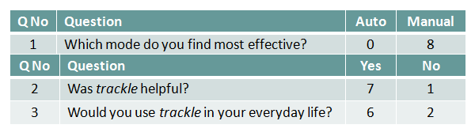
Table-1: Results of survey
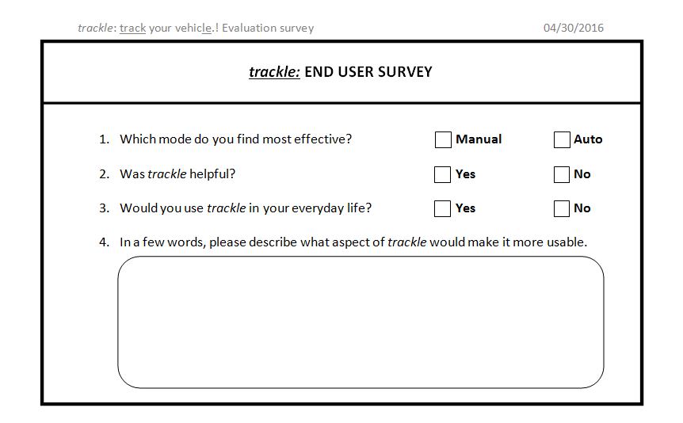
Fig.4: Sample user survey

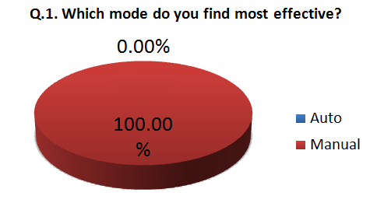
Fig.5: Pie chart for results of Q1 of survey

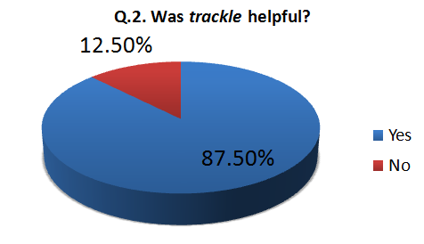
Fig.6: Pie chart for results of Q2 of survey

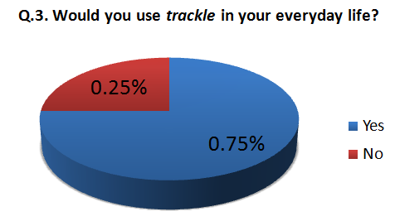
Fig.7: Pie chart for results of Q3 of survey

DISCUSSION & FUTURE WORK

Auto mode does not work in background. App should be in foreground
- GPS and Network services should be available for the app to work
- Manual Permissions required for Android 6.0 and up

Using Cloud Storage (Amazon Web Services) to store parking history data with a dedicated user login

Perform predictive analytics on stored and real time streaming data, to predict parking availability and traffic at different location at any time

Integrate with Automobile Manufacturers, Google Maps and HERE Maps:

Live parking traffic updates at different locations

Live updates on parking fare

CONCLUSION
In conclusion, we present the features that were proposed versus what was actually achieved.

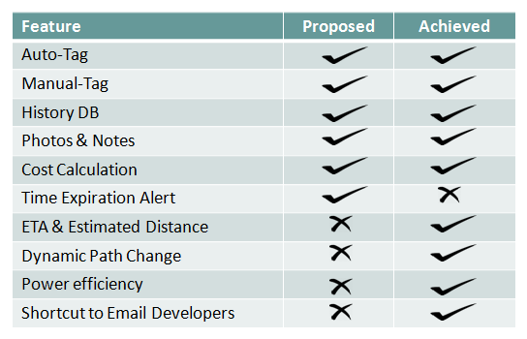
Table-2: Proposed vs. Achieved features

All proposed features, except for the time expiration alert were implemented. Three extra features that were not proposed were also included in the application – the first being the Estimated Time of Arrival at the destination and Estimated Distance to the destination. The second extra feature is the dynamic path change where the path to the destination would change dynamically i.e. the path displayed would shrink or grow as the user walks towards or away from the destination. This also helps in re-routing if the user decides to take a different path to the destination.

ACKNOWLEDGMENTS
We express our thanks to Satish Narkhede for his inputs into the functionality and usability of the application during the initial brainstorming sessions.
We also extend our gratitude to Professor Emmanuel Agu, Instructor of CS528 at Worcester Polytechnic Institute for motivating us throughout the project timeline.
We thank the eight participants who helped us evaluate our application and gave us honest feedback.

REFERENCES
- http://www.insurance.com/about-us/news-and-events/2014/05/biggest-driving-embarrassments-forgetting-where-one-parked-and-driving-over-curbs.html
- http://www.dailymail.co.uk/news/article-2688266/The-200-years-spend-looking-lost-cars-One-seven-drivers-admit-forgotten-parked-vehicle.html
- https://play.google.com/store/apps/details?id=il.talent.parking&hl=en
- Sarfraz Nawaz, Christos Efstratiou, Cecilia Mascolo. Smart Sensing Systems for the Daily Drive, IEEE computer society.
- Mind Mobile App http://dev.goldcrownelectronics.com/?page_id=360
- https://developers.google.com/android/reference/com/google/android/gms/location/DetectedActivity#constant-summary

Columns on Last Page Should Be Made As Close As Possible to Equal Length

